|  |
| --- |
| Vault Consul  DockerCompose |

Rationale

This document steps through three (3) aspects of using Vault in a Docker Container.

I. Standing up Vault without Consul

II. Adding Transit Secrets to Vault (without Consul)

III. Standup a Consul-backed instance of Vault, where both Vault and are Consul running within the same Docker Container.

The Part I concentrates on demoing (most of) the features of Vault. Part I employs flat files (a virtual file system) to make the Vault Secrets durable (secrets persist across Vault “sessions“).

Like Part I, Part III affords durability for secrets, but instead of using a virtual file system, Part III leverages Consul to provide a cluster-aware, durable persistence layer for the Vault Secrets.

All three parts show Vault running collocated, within a single Docker Container.

So, Docker-Compose is used throughout each example.

Part III builds upon the same configuration and directory structure as is utilized in Part I – with mods made to the content of the same key files to accommodate the addition of Consul, of course.

Both the Vault image and the Consul image are HashiCorp’s Docker Images



Architecture

This Each of the Vault and Consul images come from Hashicorp, via their respective Dockerfiles, and both execute within the same container, which leverages an economical Alpine Linux distro.

Alpine is a Linux OS which is optimized for containers, like Docker, and is a derivative of BusyBox.

<https://en.wikipedia.org/wiki/BusyBox>

<https://en.wikipedia.org/wiki/Alpine_Linux>

Each of the Dockerfiles are cited within the canonical build tag inside the canonical docker-compose.yml file.

Vault and Consul are together configured inside the yml file as (collocated) services. Each declaration is an eponymous entry, within the canonical root entry (services) of a standard docker-compose.yml file.

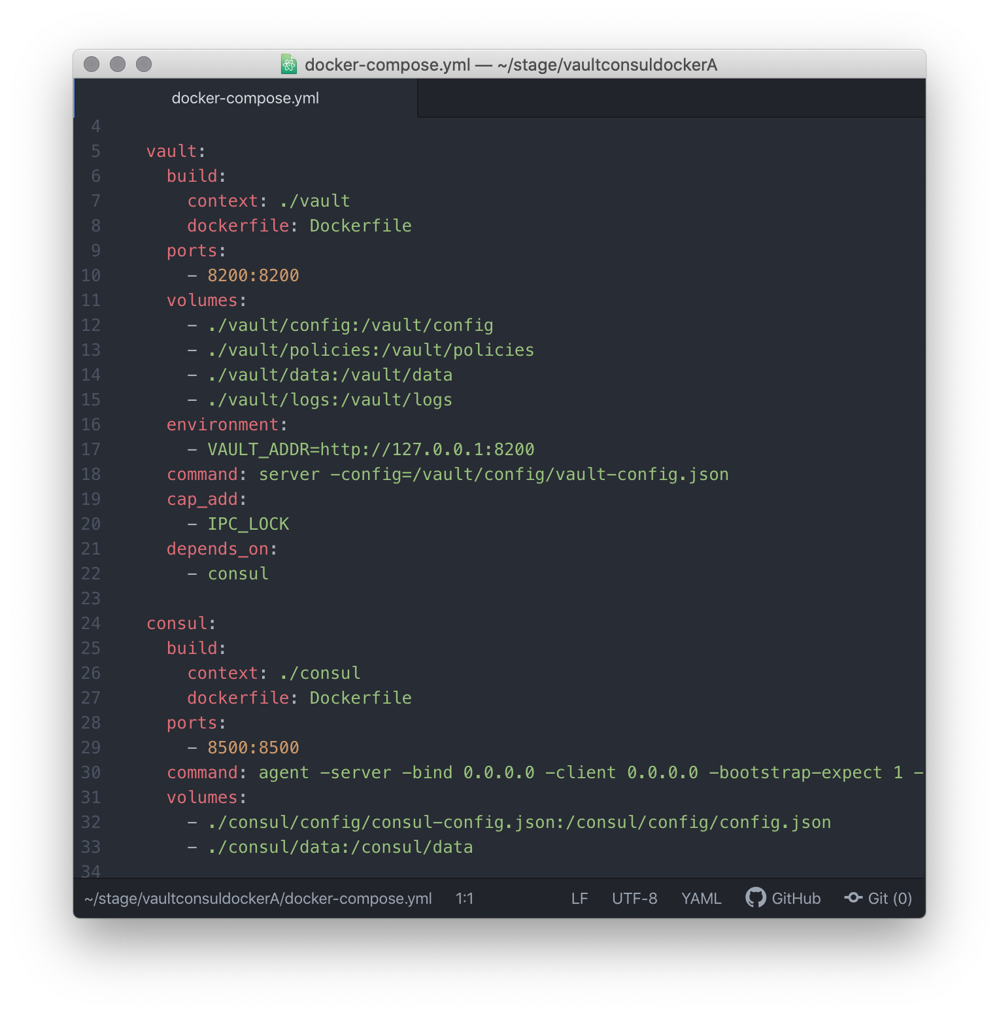

Project Structure

Below, the superstructure of the project is shown alongside by the same structure, populated with the various configuration files that are necessary to get things running, and some application-generated artifacts.

The next section describes the configuration files.

|  |  |
| --- | --- |
|  |  |

Configuration

Below, in the vault/config/vault-config.json file: a. Vault has been configured to use Consul (port 8500) as its backend; b. A listener for Vault is established on port 8200; c. TLS has been disabled (as this is a demo); d. The Vault UI has been enabled.

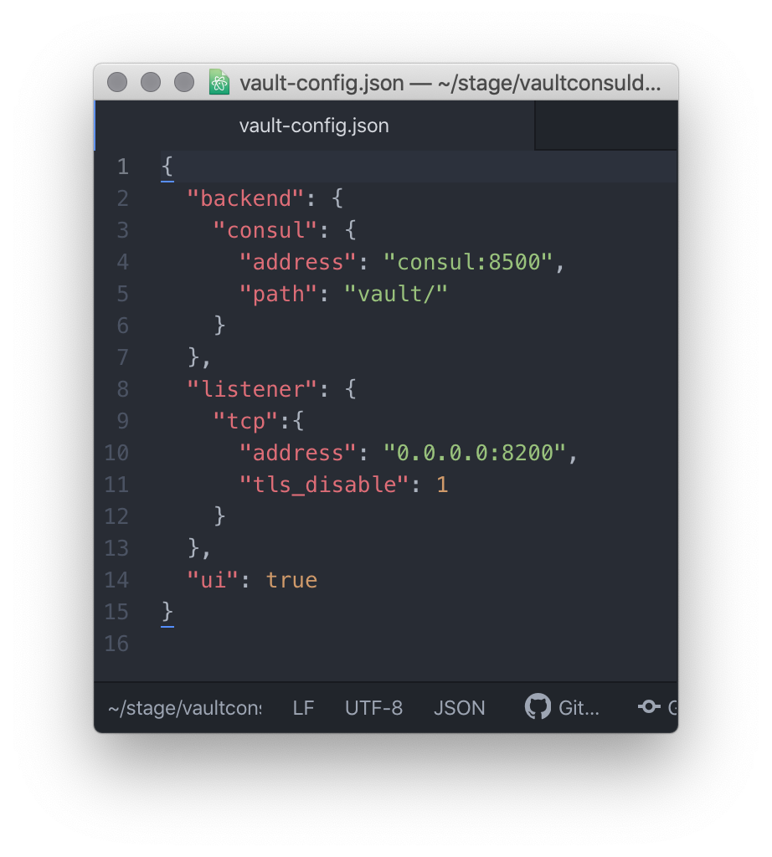



ßuild

The scaffolding of the container happens in two passes (there are 2 services in the container: Consul, Vault. The canonical CLI command to get things configured within the (detached) Docker Container:

docker-compose up -d -build

NB Each of the two builds shown happen by means of labeled Steps; they contribute to what are called Docker Layers. Only the last layer (top-of the stack, last in the listing) is *writeable* – this writeable layer is the canonical entrypoint.

For the Vault Service, it is denoted like this:



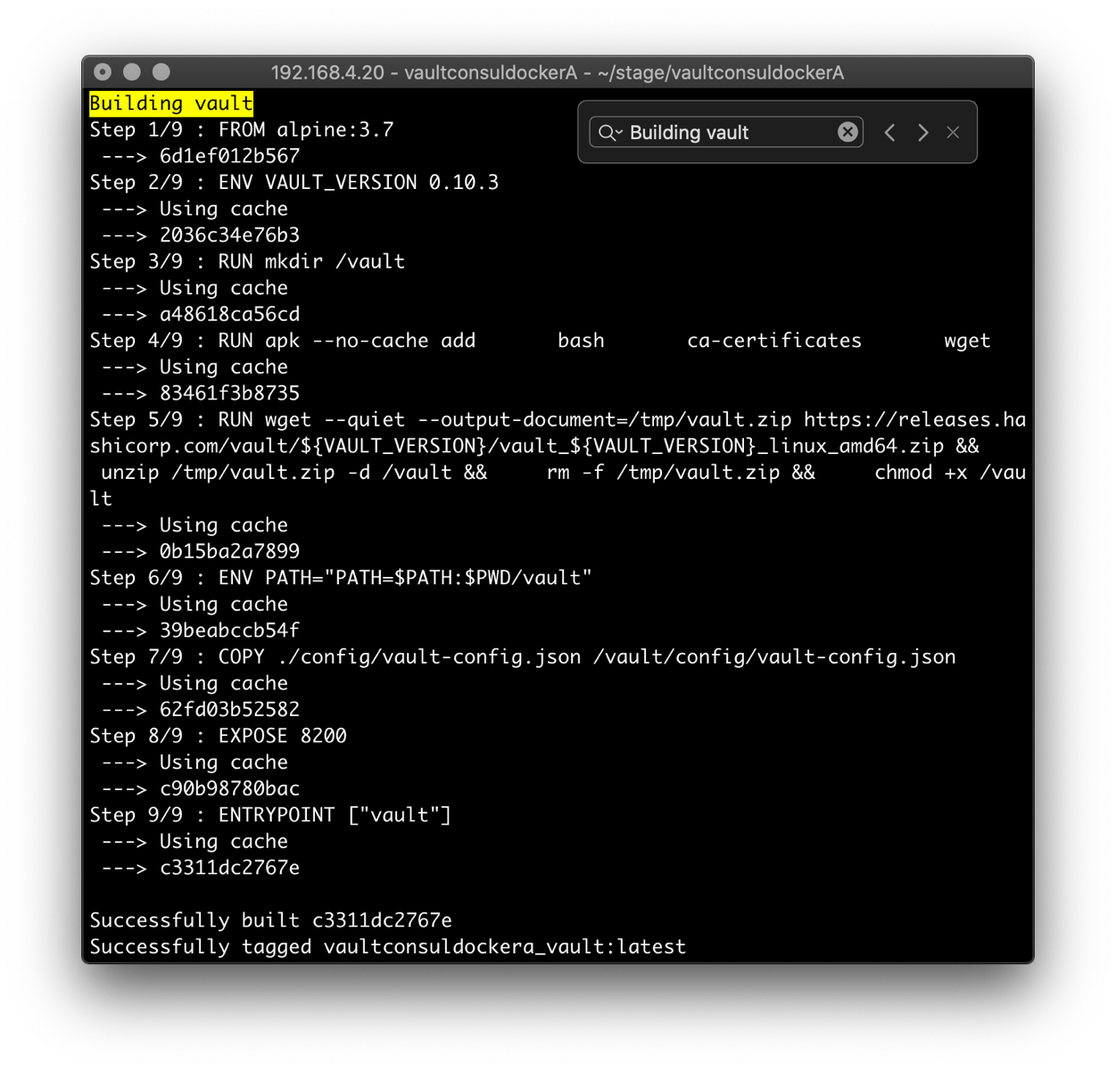

Likewise, for the Consul Service, the entrypoint is denoted like this:



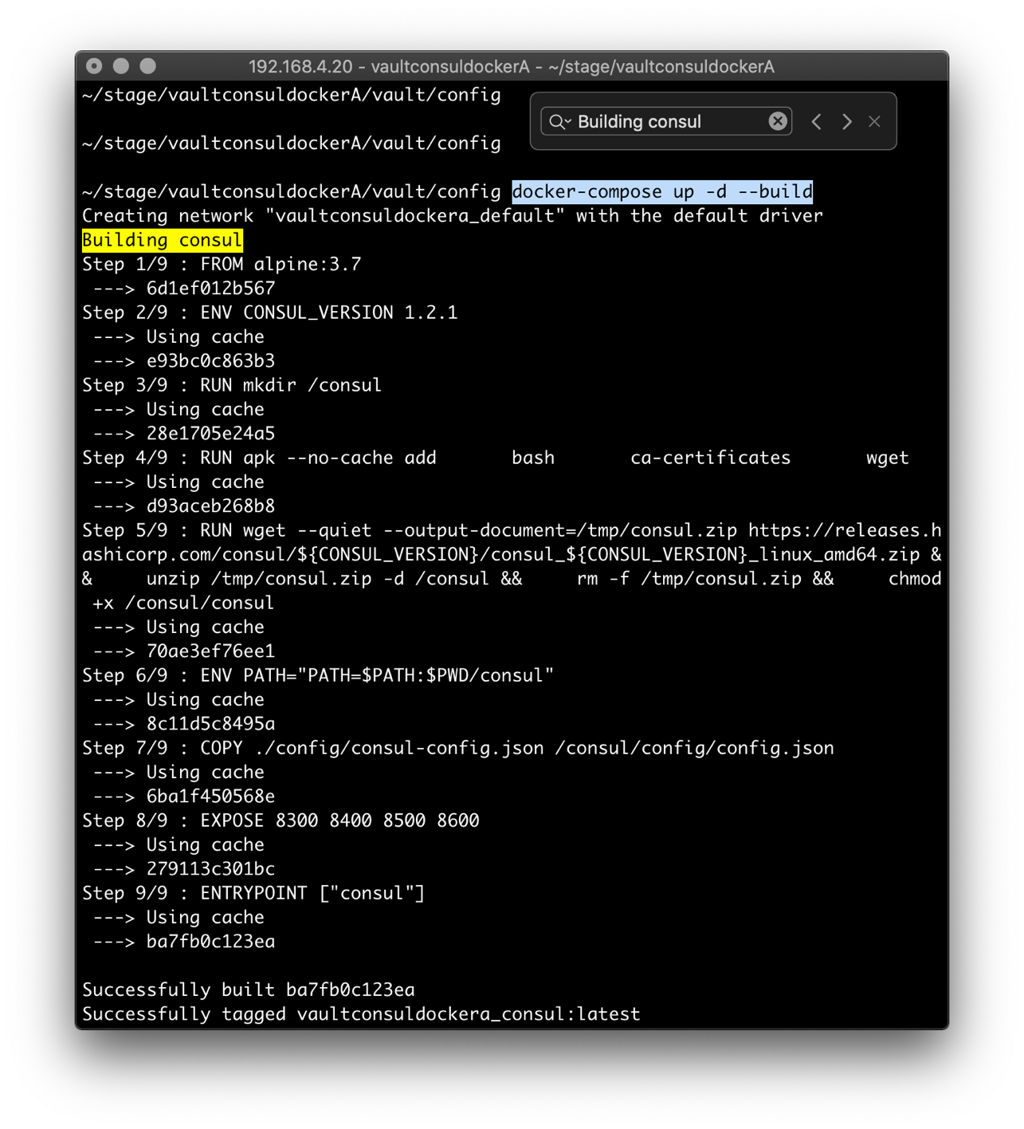

Finally, the configuration displays a tombstone. Notice a third entry – it is another consul node in a Consul Cluster. This is a remnant from another tutorial (and is out of scope for this document).

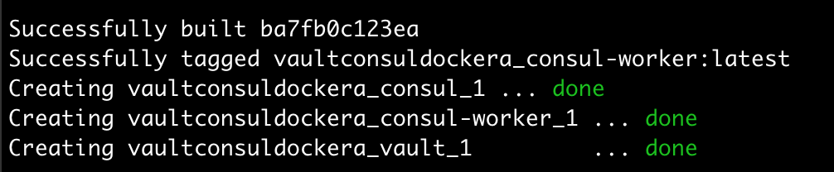



Spinup

The CLI command to get the Docker Container running:

docker-compose exec vault bash

This puts you smack inside the Docker Container, at a ßash command prompt.

Issue this command (inside the Docker Container) to initialize Vault:

vault operator init

Upon issuing the above command, you’ll encounter an important set of Vault-specific messages which involve the identities of five (5) cryptographic keys which allow you to unseal the initially-sealed Vault.

The keys will resemble those shown below.

SAVE THEM, along with the value of the Initial Root Token

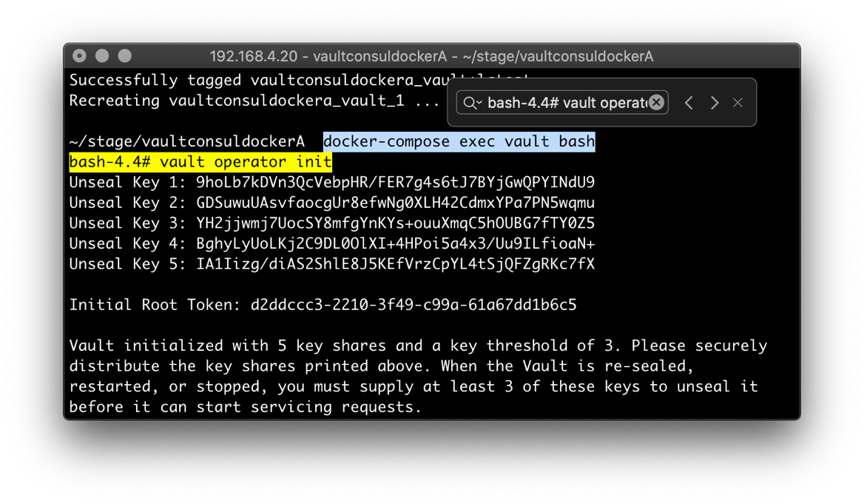

The keys shown above are specific to a Vault image. They’re involved in a cryptographic algorithm called Shamir’s Secret Sharing.

Adi Shamir is co-inventor of the [Rivest–Shamir–Adleman](https://en.wikipedia.org/wiki/RSA_(algorithm)) (RSA)

[algorithm](https://en.wikipedia.org/wiki/Algorithm) (along with [Ron Rivest](https://en.wikipedia.org/wiki/Ron_Rivest) and [Len Adleman](https://en.wikipedia.org/wiki/Len_Adleman)).

|  |  |
| --- | --- |
| You know, RSA tokens.  ref <https://en.wikipedia.org/wiki/Shamir%27s_Secret_Sharing>  ref <https://en.wikipedia.org/wiki/Adi_Shamir>The keys shown |  |

Take any 3 of the (5) keys, apply them as arguments to the command vault operator unseal:

vault operator unseal MYCLb4f2x9G6ZSZfUYQlYDq3LKX0ipnSrI+5Bgtg/X9P

vault operator unseal A7b637KnCR09n+vKZqMU86V3dtZs48zhE+gqa9ilUd/P

vault operator unseal dsIYekEedOgqwOhQGyKotW196PgfOCG0EA87Ke0AZown

Next, there will be 2 screen shots depicting the second and third of the three

commands needed to unseal Vault – they are using the keys shown above.

Notice that the last of which reports ‘sealed false’.

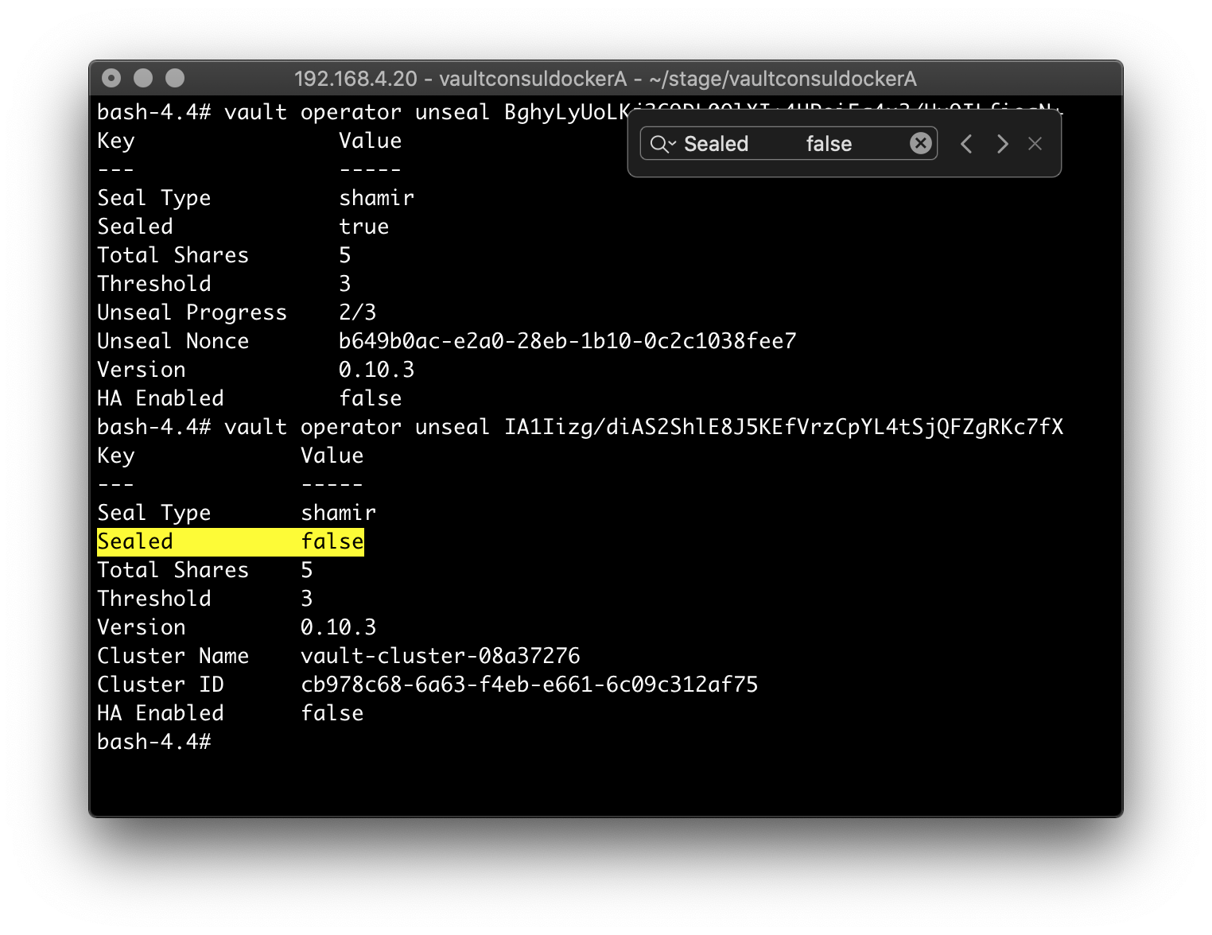

When the Vault server restarts, it reverts to a Sealed state.

You can seal Vault manually, too.



Now, use the administrative token to login. You’ll see the default policies associated w/ the root account.

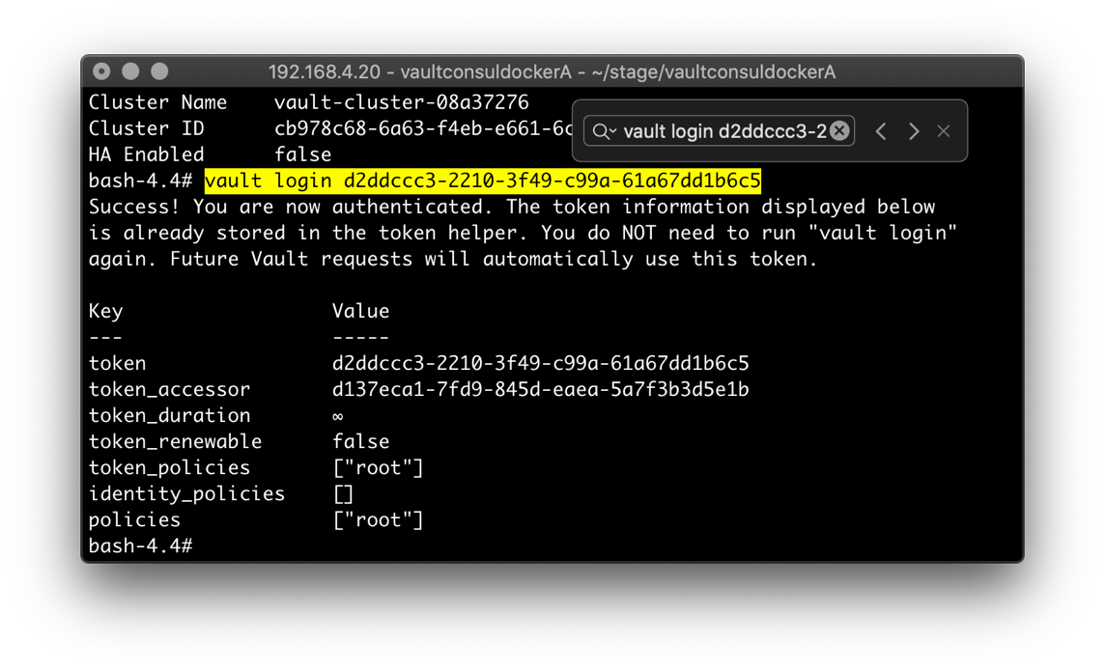

NB Usually, login is divided between 3 people, each with a token.



Audit Trail

As administrator, establish an audit with this pair of commands:

vault audit enable file file_path=/vault/logs/audit.log

vault audit list

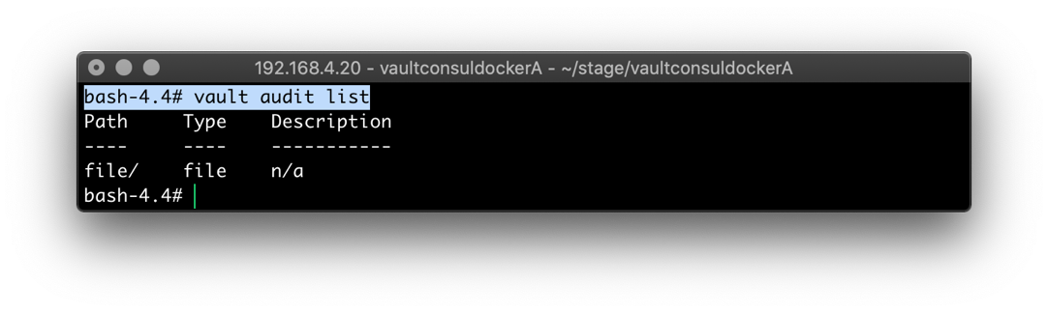



Secrets – as Admin, Inside-of Vault

As administrator, you have the option to perform CRUD operations on Static Secrets.

Note that you can be outside of Vault and do the same CRUD. This external access is accomplished by using Vault’s HTTP API (more later).

Besides Static Secrets, there are also Dynamic Secrets, and Transit Secrets – the latter known as either Cryptography as a Service or Encryption as a Service (CaaS/EaaS).

The last two are out of scope for this document.



By default, Vault uses a key-cryptography system named KV.

The verbs semantics are that of a traditional software dictionary/map – e.g. put/get.

The last concept is the path. Each key-cryptography system (there are several) has a reserved path-specifier. For the KV key-cryptography system, it’s secret (I know).

Let’s use the above concepts to mess with Vault Secrets.



For an ADD, you have license with the last three tokens, the first four are boilerplate.

vault kv put secret/somepath passcode=nneka

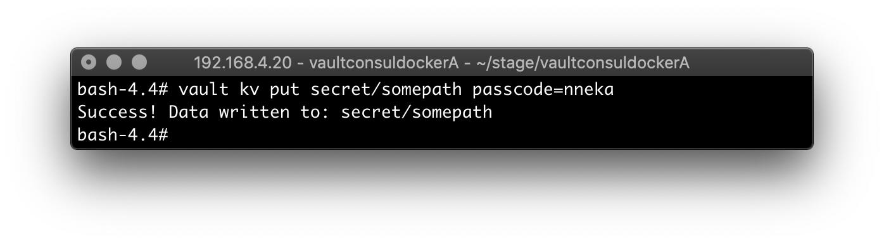

Get back the key and the value (as a pair):

vault kv get secret/somepath

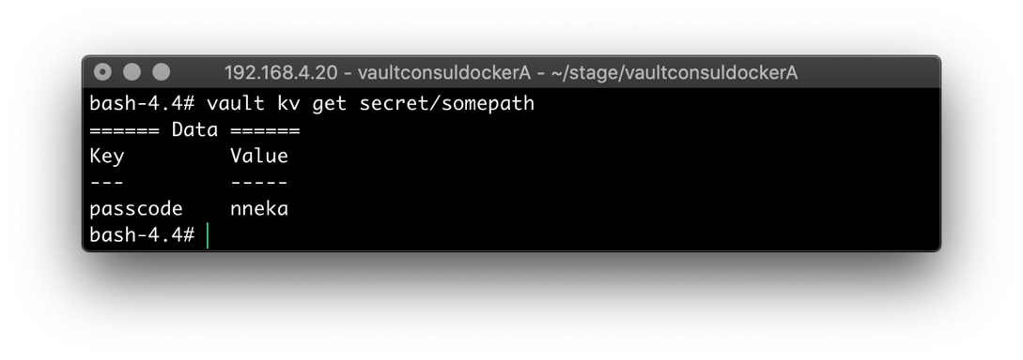



Enable versioning (for the KV System):

vault kv enable-versioning secret

For an UPSERT, you have license with the last three tokens, the first four are boilerplate.

vault kv put secret/somepath passcode=egbuna

Notice the versioning metadata is now returned, along with the current state. This can be extremely useful.

Get the first version (or any other version) – get the pair.

vault kv get -version=1 secret/somepath

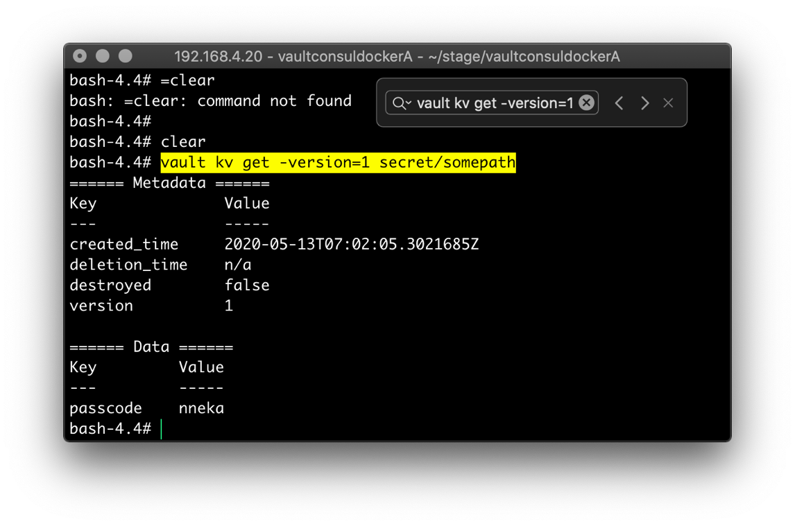

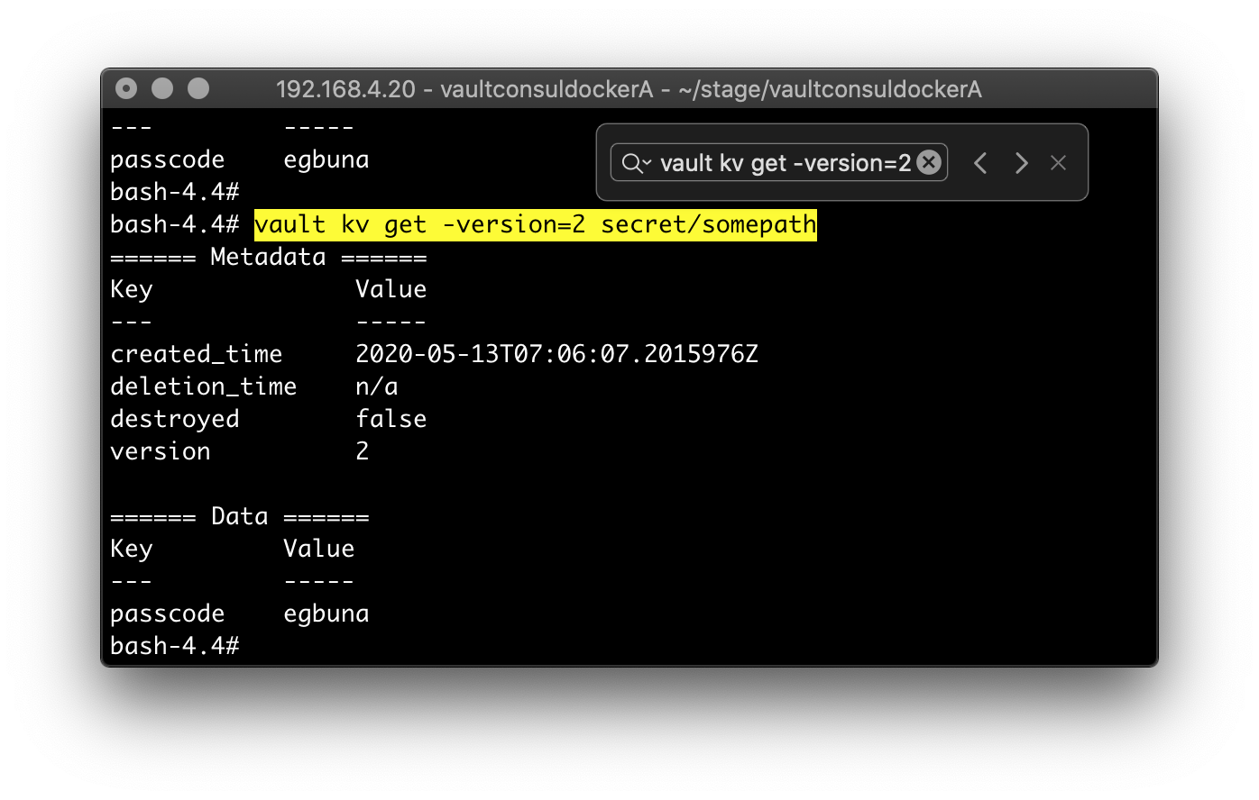

Secrets – as Admin, Outside-of Vault

As administrator, you can also access Vault from another ßash Shell.

To accomplish this, you have to map an environment variable (ala 12-Factor App).

export VAULT_TOKEN=d2ddccc3-2210-3f49-c99a-61a67dd1b6c5

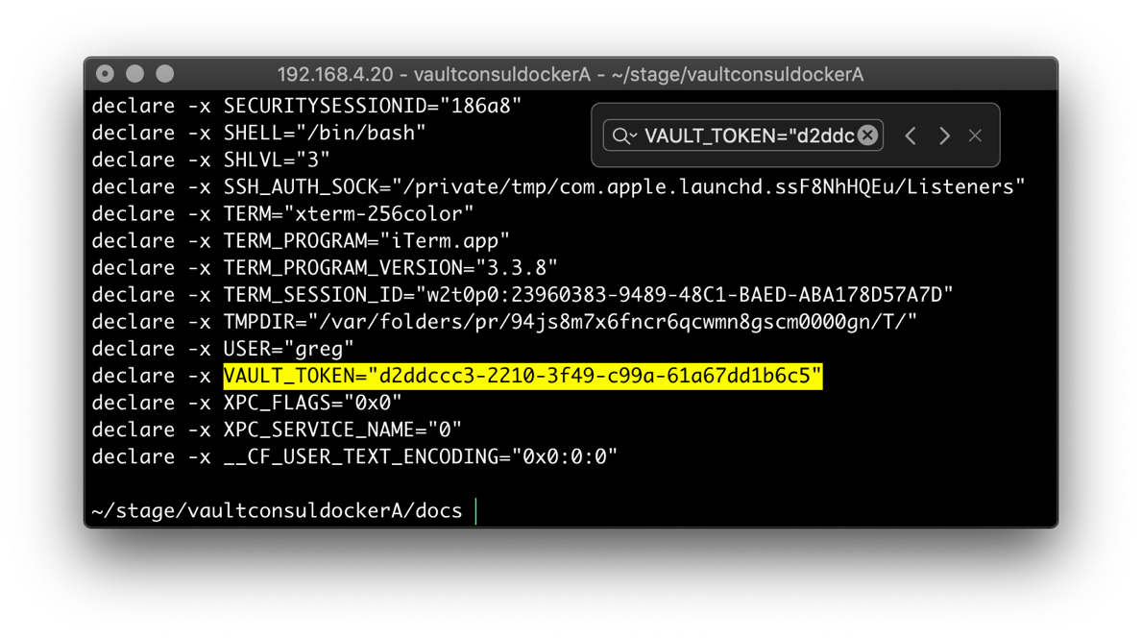

Utilize Vault’s HTTP API by leveraging cURL, to do an UPSERT to version 2 of the secret path somepath:

TODO



Secrets – as Admin, Outside-of Vault

And, there is the option of using Vault’s console. Login using the same root token value that you previously exported to the VAULT_TOKEN.

In my case, the value of the root token is: [ d2ddccc3-2210-3f49-c99a-61a67dd1b6c5 ]

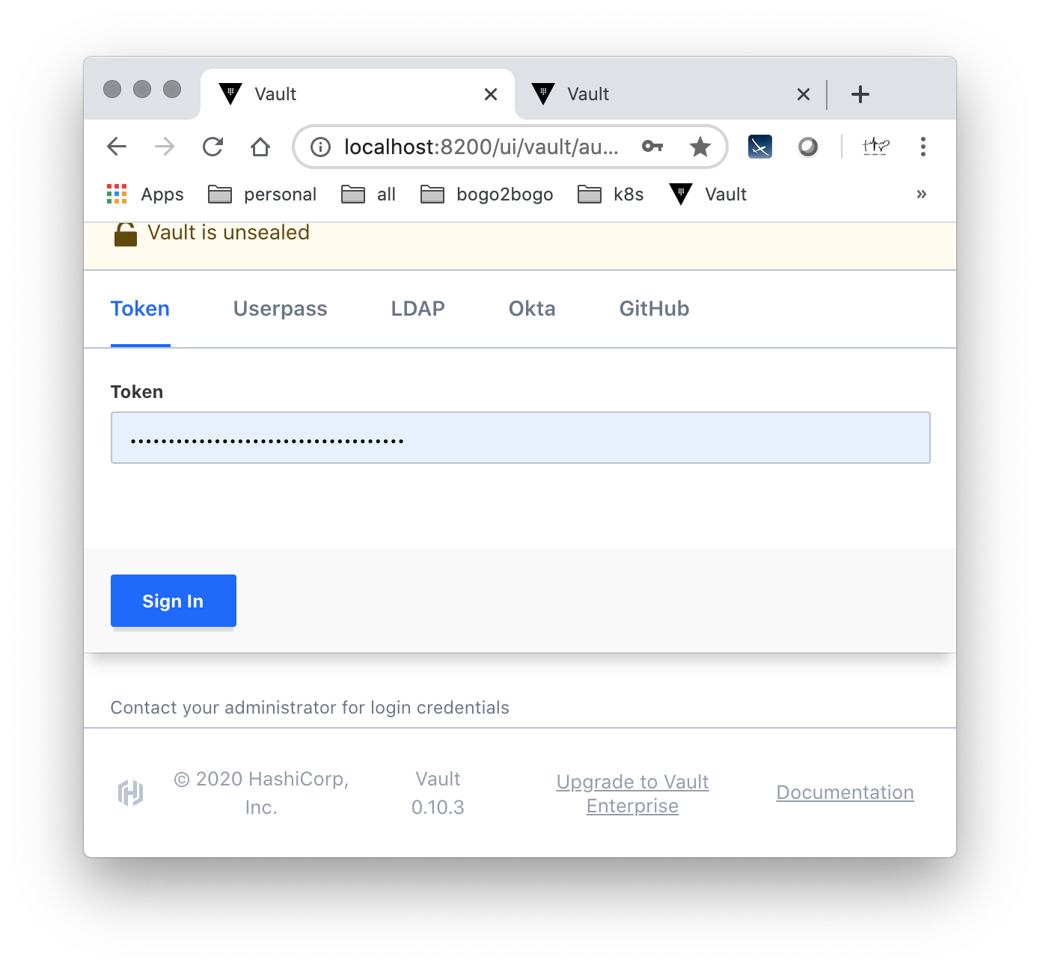

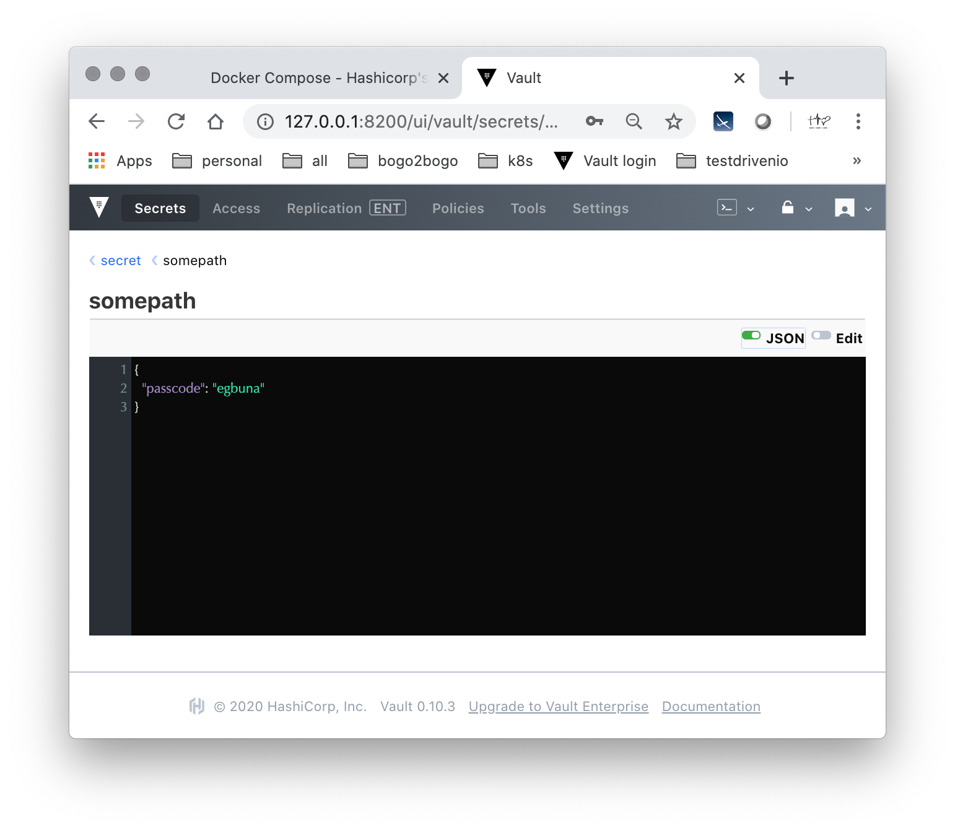



Policies

As administrator access is granted in a wide scope. Here is how to establish a policy that has read-only access. It consists of a few steps, within Vault and outside of Vault.

In the client environment (outside of Vault) create inside the vault/policies/ directory, a file that is named app-policy.json. Add the content shown below.

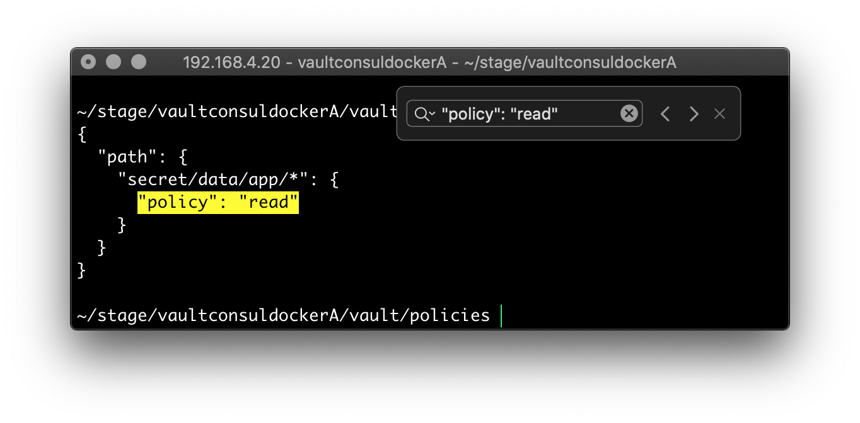

Next, at the ßash Shell prompt *inside* of Vault, create the new policy that matches the policy shown in the file above using this pair of CLI commands:

vault policy write app /vault/policies/app-policy.json

vault token create -policy=app

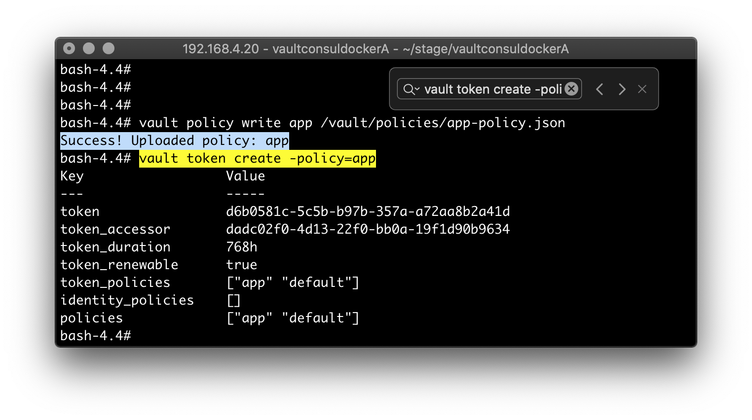

Now – outside of Vault, at a command prompt – you can verify that the read policy is intact:

curl -H "X-Vault-Token: $VAULT_TOKEN" -X GET <http://127.0.0.1:8200/v1/secret/data/hello>

Remember to export the alternative token that is associated with the new policy as the environment variable (ala 12-Factor App):

export VAULT_TOKEN= d6b0581c-5c5b-b97b-357a-a72aa8b2a41d

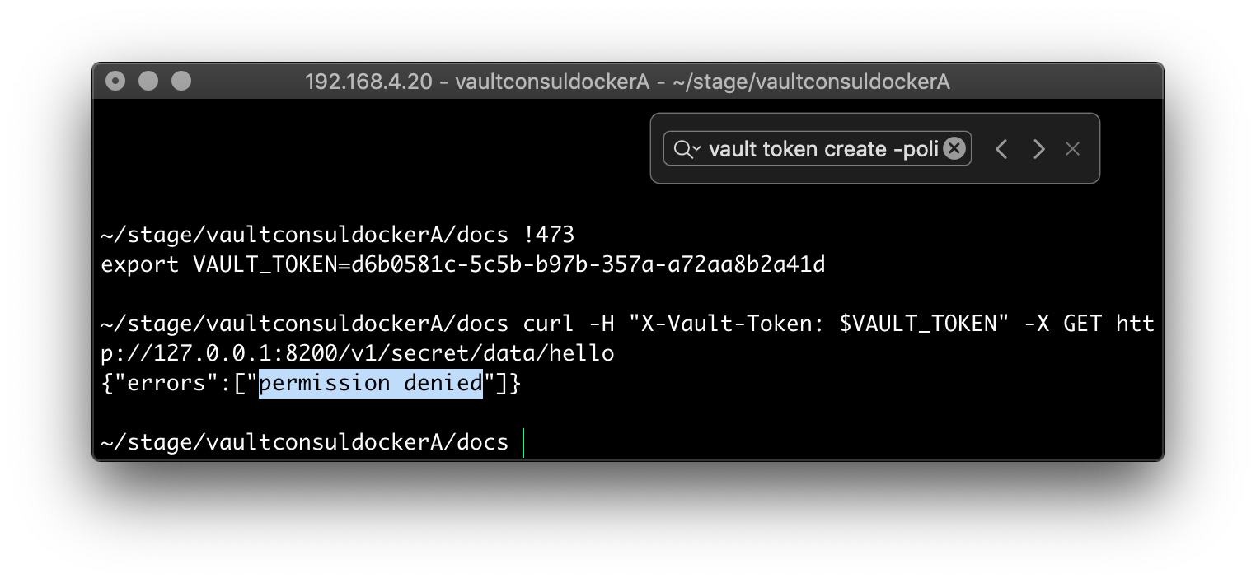

The FAIL is due to the policy configuration in the vault/policies/app-policy.json file. The constraint found on lines 3-4 says that the policy enforces reads only from the app path:

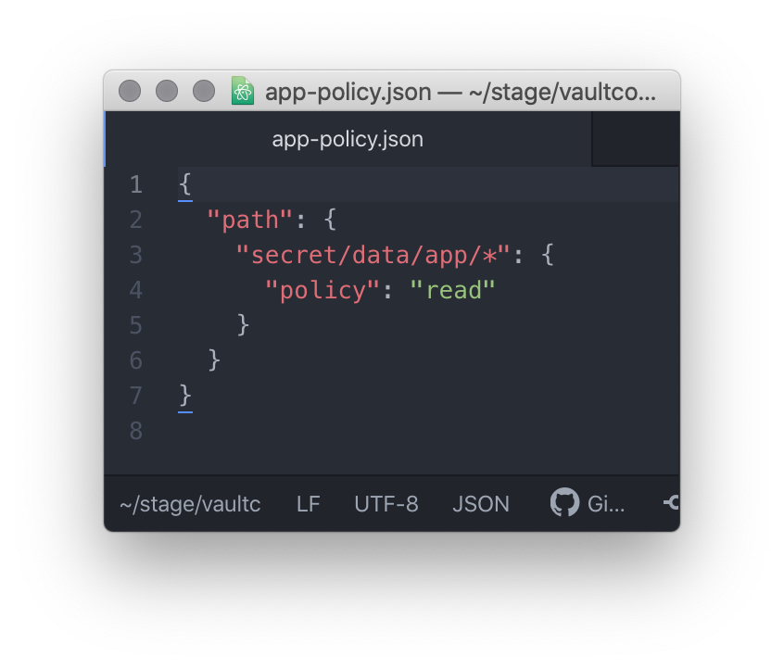

Since the secret that we are trying to access above, was not deposited (kv put) along a path that includes the /app “edge”, it remains inaccessible.

Let’s demonstrate using the new read policy by creating a secret which incorporates the new /app edge, and then retrieve it – using the pair of complementary commands found on the next page.

The first command is issued within a Vault ßash Shell.

vault kv put secret/app/test high=low

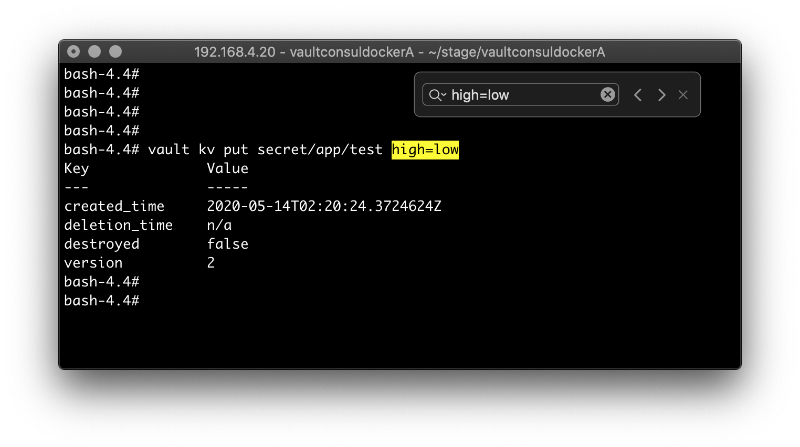

The second command is issued in a ßash Shell outside of Vault.

curl -H "X-Vault-Token: $VAULT_TOKEN" -X GET <http://127.0.0.1:8200/v1/secret/data/app/test>

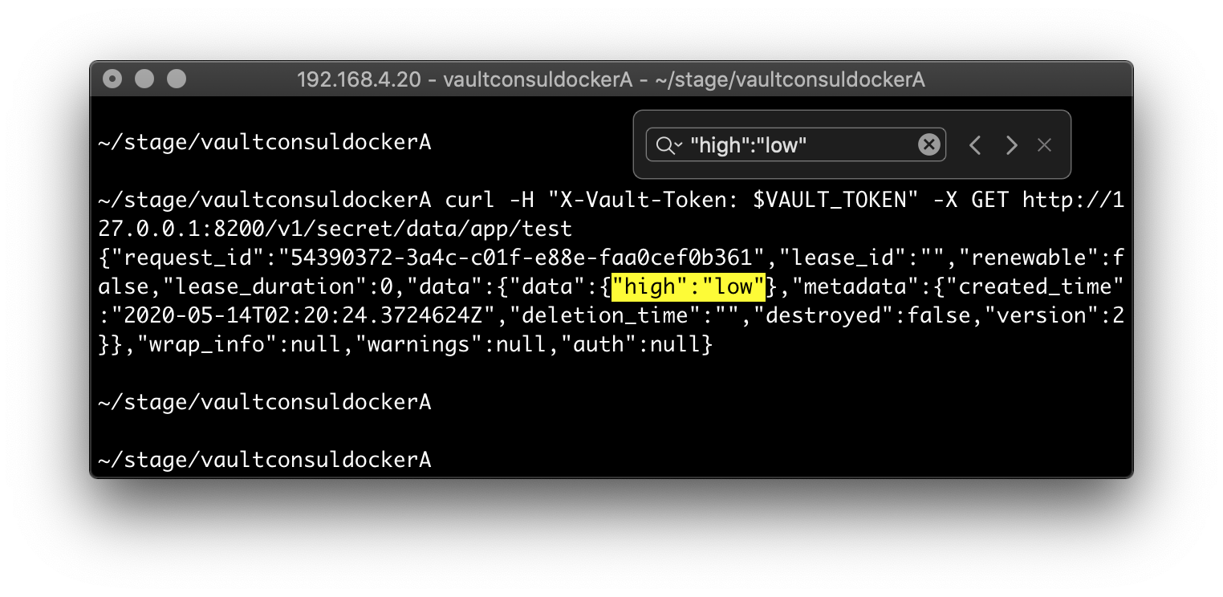

Lastly, Policies can be administered via the Vault Console (see next page)

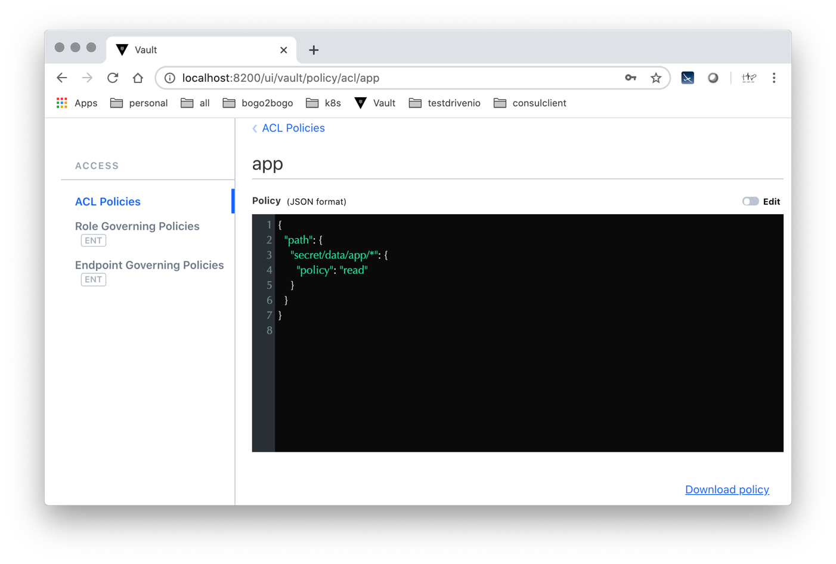



PART II

Transit Secrets – CaaS/EaaS (CLI toolset)

Besides the Static Secrets and Dynamic Secrets which have been previously covered, Vault also offers Transit Secrets – also known as either Cryptography as a Service or Encryption as a Service (CaaS/EaaS).

HashiCorp uses the term Transit Secrets to denote its ability to encrypt/decrypt data “in-transit”.

ref <https://doubleoctopus.com/security-wiki/cloud-services/security-as-a-service/>

To enable-encrypt-use Vault’s Transit Secrets, return to a ßash Shell inside of Vault – you may have to unseal again, depending upon if you have stopped Vault – and issue this trio of CLI commands:

vault secrets enable transit

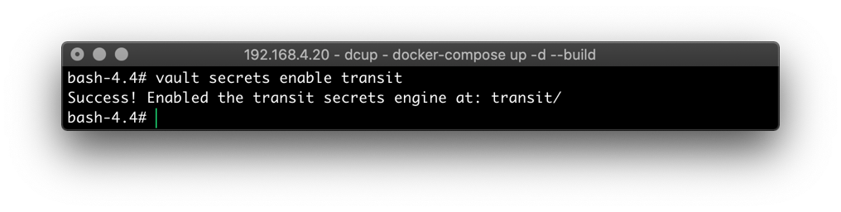

To enable a transit encryption key, issue:

vault write -f transit/keys/any

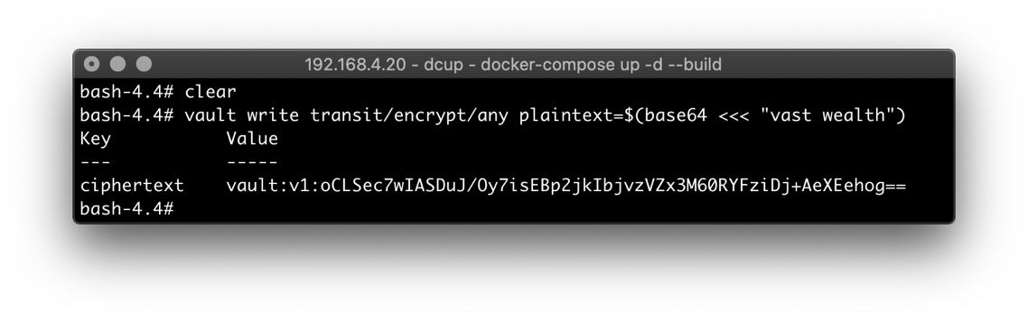

To utilize the newly-created transit encryption key, issue:

vault write transit/encrypt/any plaintext=$(base64 <<< "vast wealth")

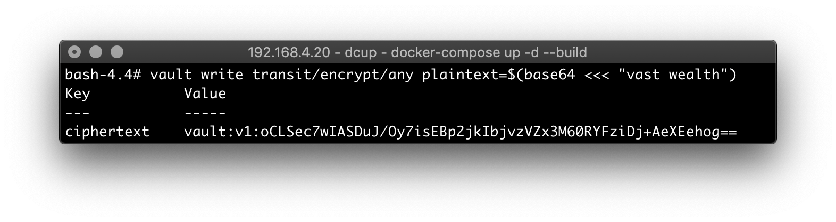



To decrypt-and-decode Vault’s Transit Secrets, within a ßash Shell inside of Vault issue this pair of CLI commands:

vault write transit/decrypt/any ciphertext=vault:v1:oCLSec7wIASDuJ/Oy7isEBp2jkIbjvzVZx3M60RYFziDj+AeXEehog=

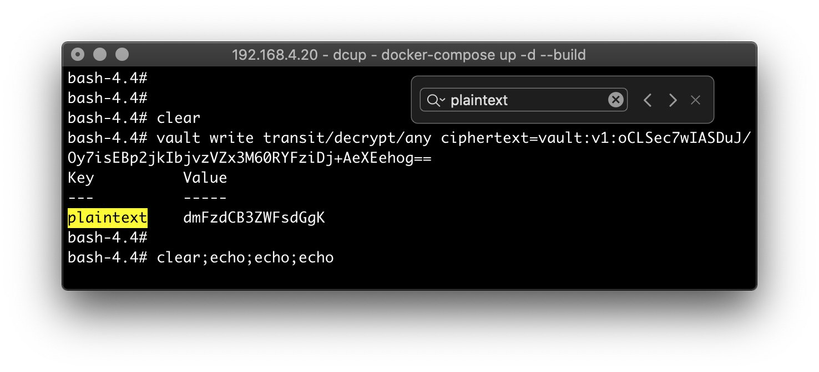

To decode the (now decrypted) Transit Secret, plugin the decrypted value when issuing this CLI command:

base64 -d <<< "dmFzdCB3ZWFsdGgK"

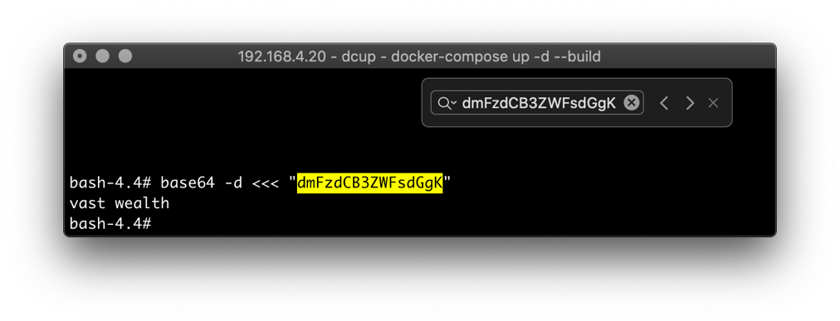



Transit Secrets – CaaS/EaaS (UI toolset)

To look at Transit Secrets with the UI webpage, login and navigate to the Secrets menu option.

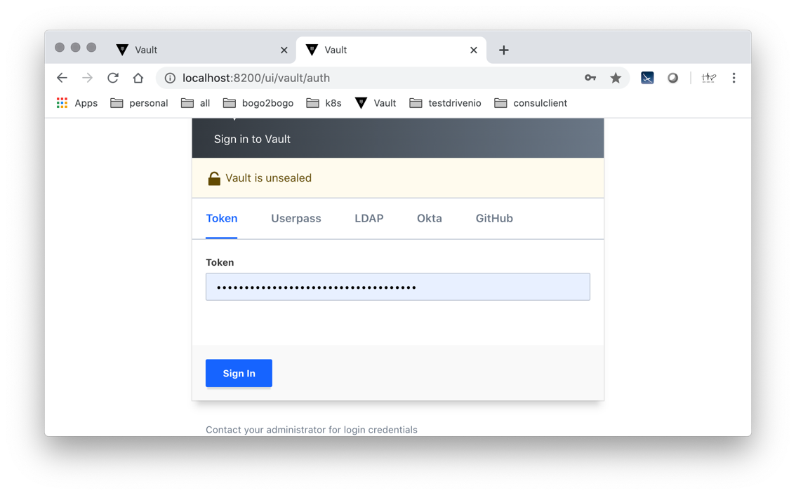

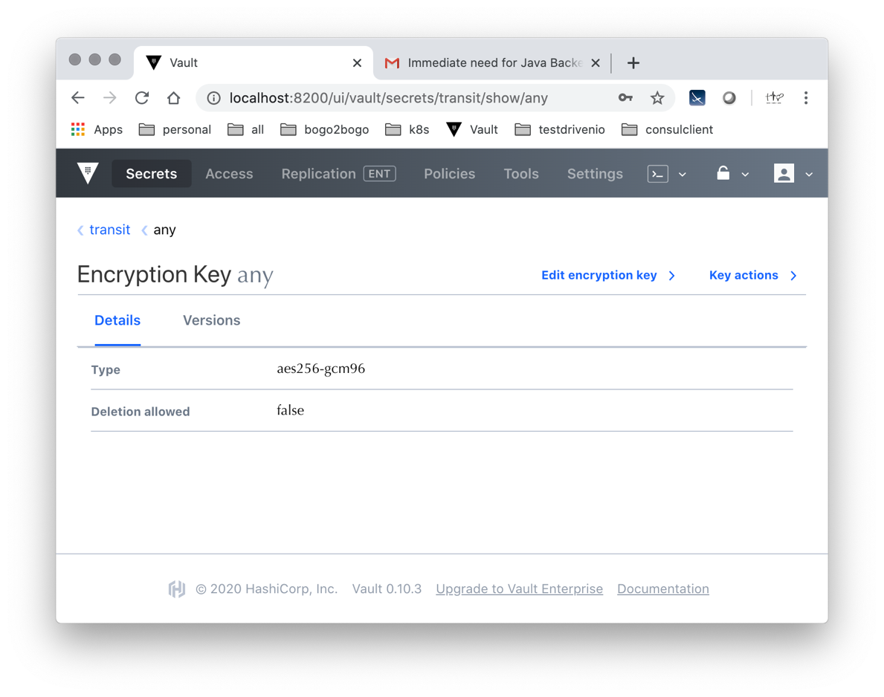



PART III

Vault and Consul (clustered)

Using Consul as the persistence layer for Vault – in preference to a VFS – affords the capability of using Vault in a clustered, cloud-native environment.

There are several steps to get Consul configured to run (collocated) in the same Docker Container with Vault.

All of the steps outline next are provisional

They are issued outside of the Docker Container



a. Add an entry (lines 20-9) and map Vault to it (lines 17-8) in the canonical docker-compose.yml file, as shown below.

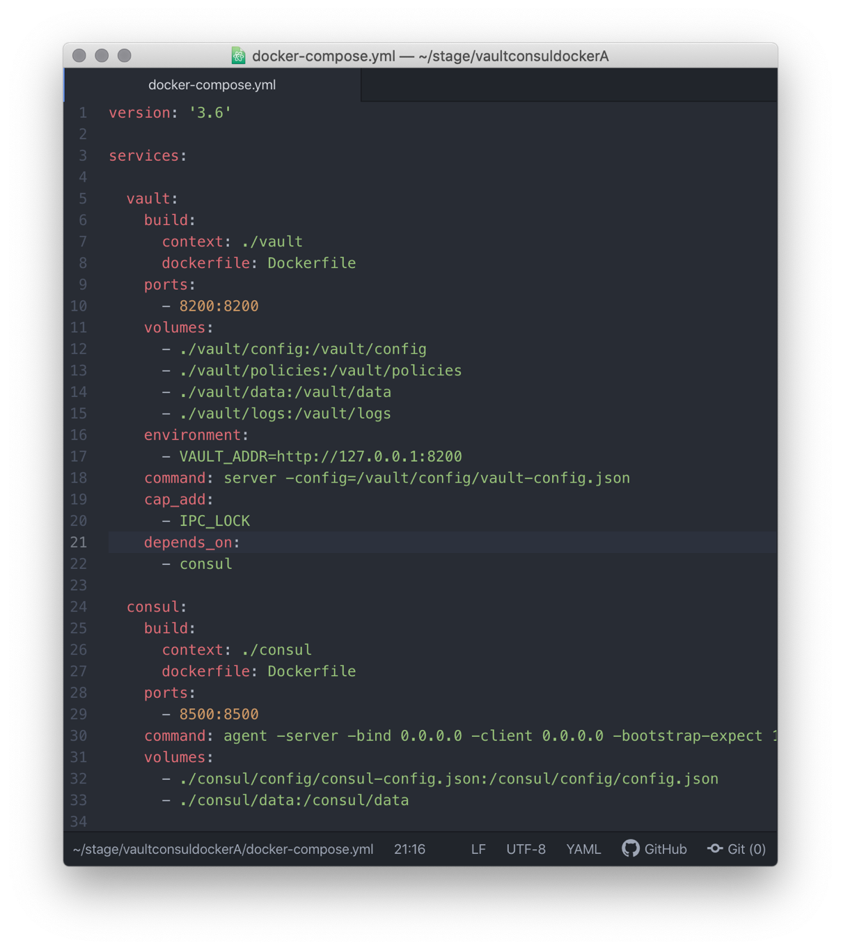

b. Next, account for the reified path mentioned in the above configuration specs by creating the directory structure, then adding a Dockerfile specific to Consul in the directory that you create.

The name of the directory/folder is consul, and it should be rooted in the application root (whatever you have chosen to name your application root).

For example, I am rooting the app here:

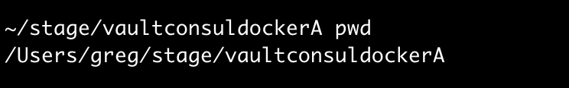

So, if you’d like:

Inside of your app root directory/folder, issue:

mkdir -p consul

continues

c. Within the consul directory/folder you just created, also create a Dockerfile, using a HashiCorp image:

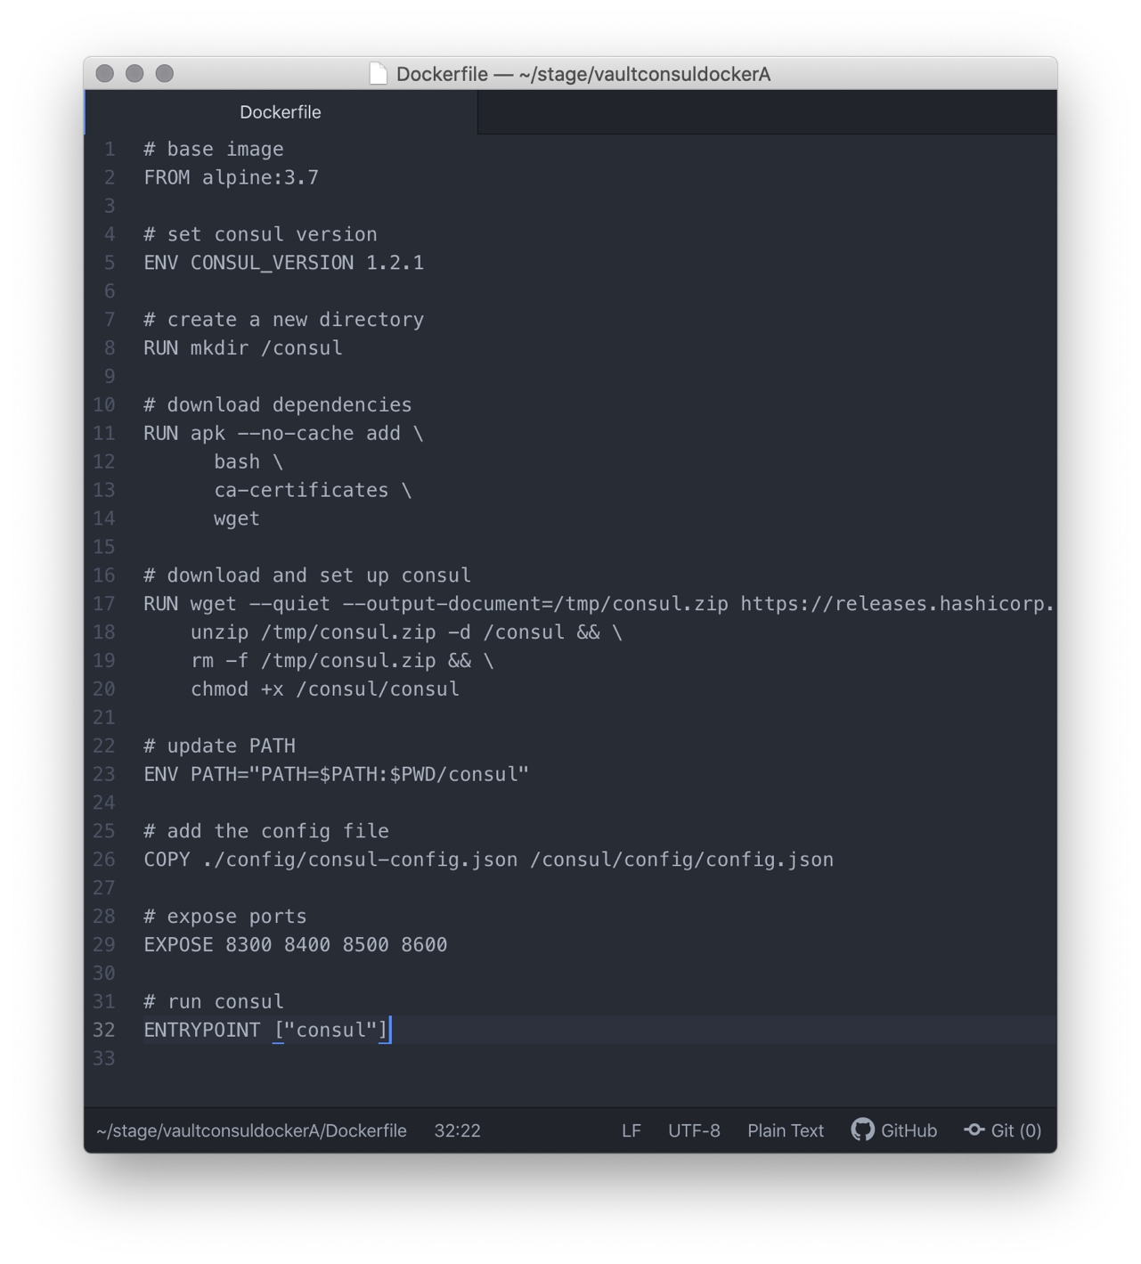

continues

d. Within the consul directory/folder you just created, also create a directory structure, by issuing these commands:

mkdir config

mkdir data

cd config/

touch consul-config.json

The created directory structure should resemble:

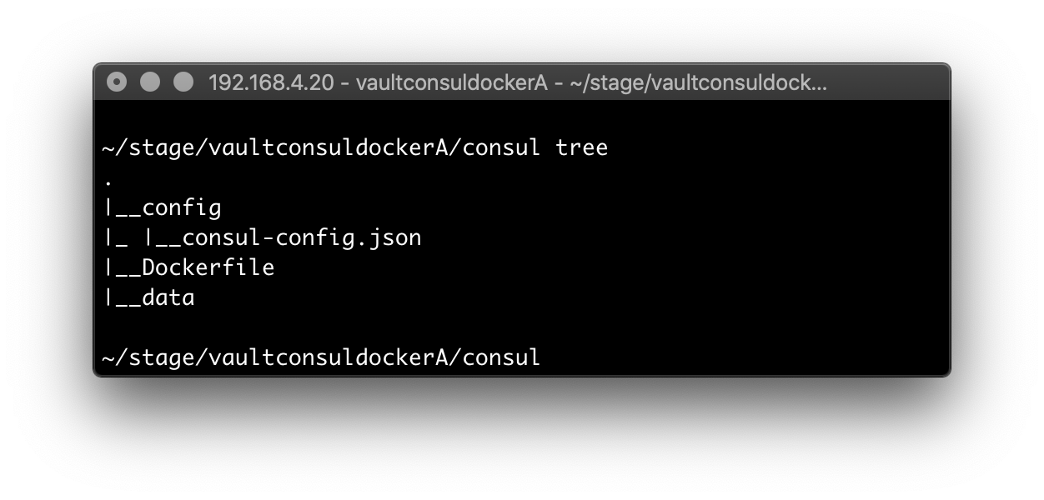

continues

e. Within the consul/config/ directory, create the needful consul config file – consul-config.json – with this content:

{

"datacenter": "localhost",

"data_dir": "/consul/data",

"log_level": "DEBUG",

"server": true,

"ui": true,

"ports": {

"dns": 53

}

}

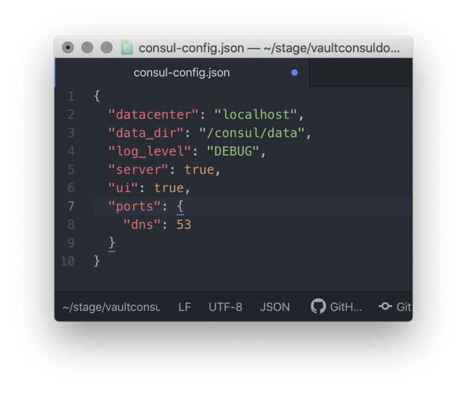

f. Modify the vault/vault-config.json file to change the persistence mechanism from a virtual file system to Consul instead.

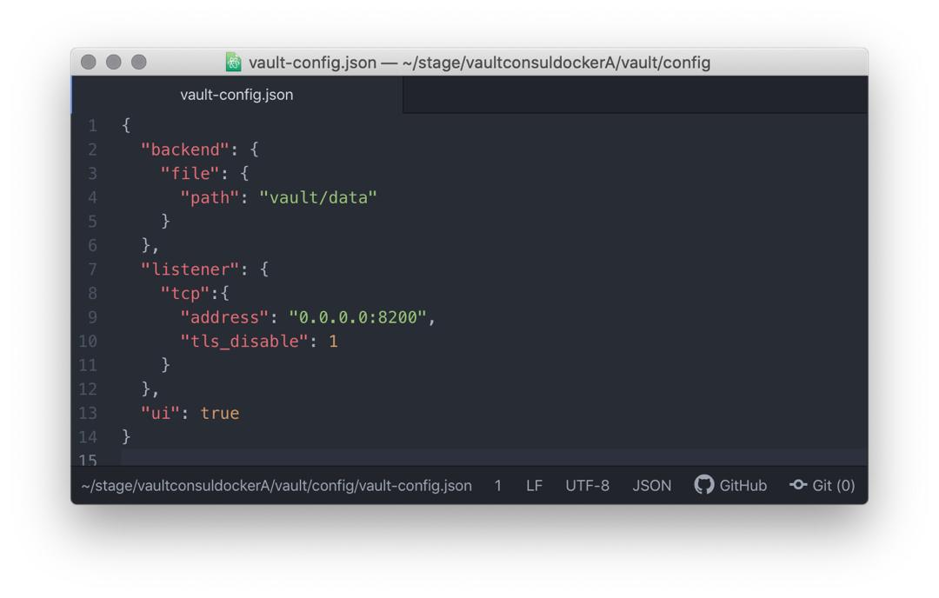

g. Cycle Docker to get the new configuration (files) – the Dockerfile file, the vault-config.json file, and consul-config.json file – registered with the Docker Container.

NB After stopping the Docker Container, but before restarting it, be sure to purge the vestiges of the virtual file system from two key directories/folders.

These artifacts live here:

./consul/data

./vault/data

Below are the four commands to use to: 1. Bring down the Docker Container; 2. Regenerate w/ the new configuration; 3. Restart the Docker Container; 4. Verify the new configuration (the addition of Consul to the Docker Container).

docker-compose down

docker-compose up -d –build

docker-compose exec vault bash

docker ps --format "table {{.ID}}\t{{.Names}}\t{{.Status}}"

continues

This command launches 2 distinct build Stages (Consul, Vault):

docker-compose up -d –build

Consul [1/2]

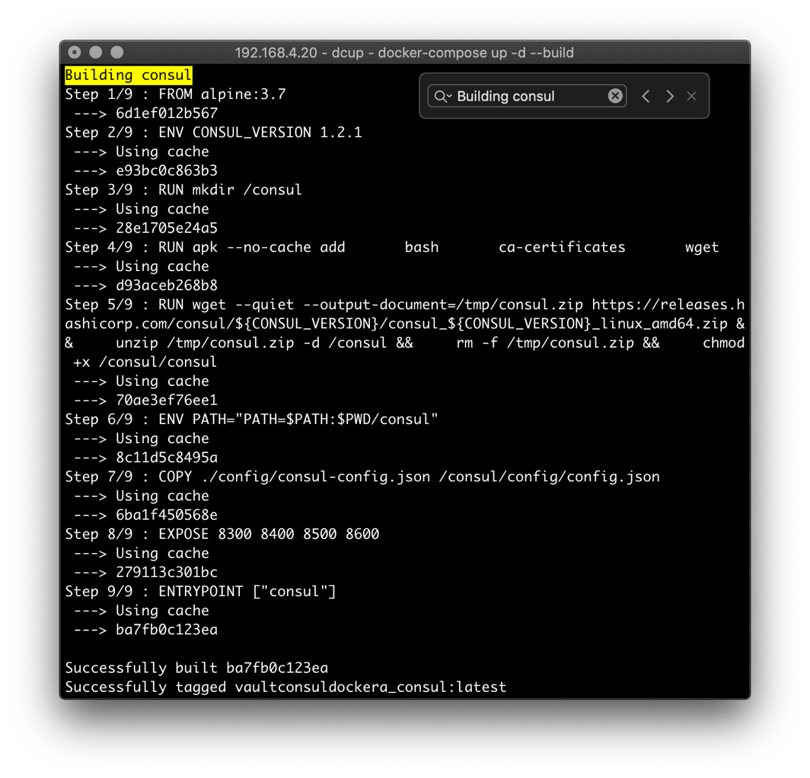

Vault [2/2]

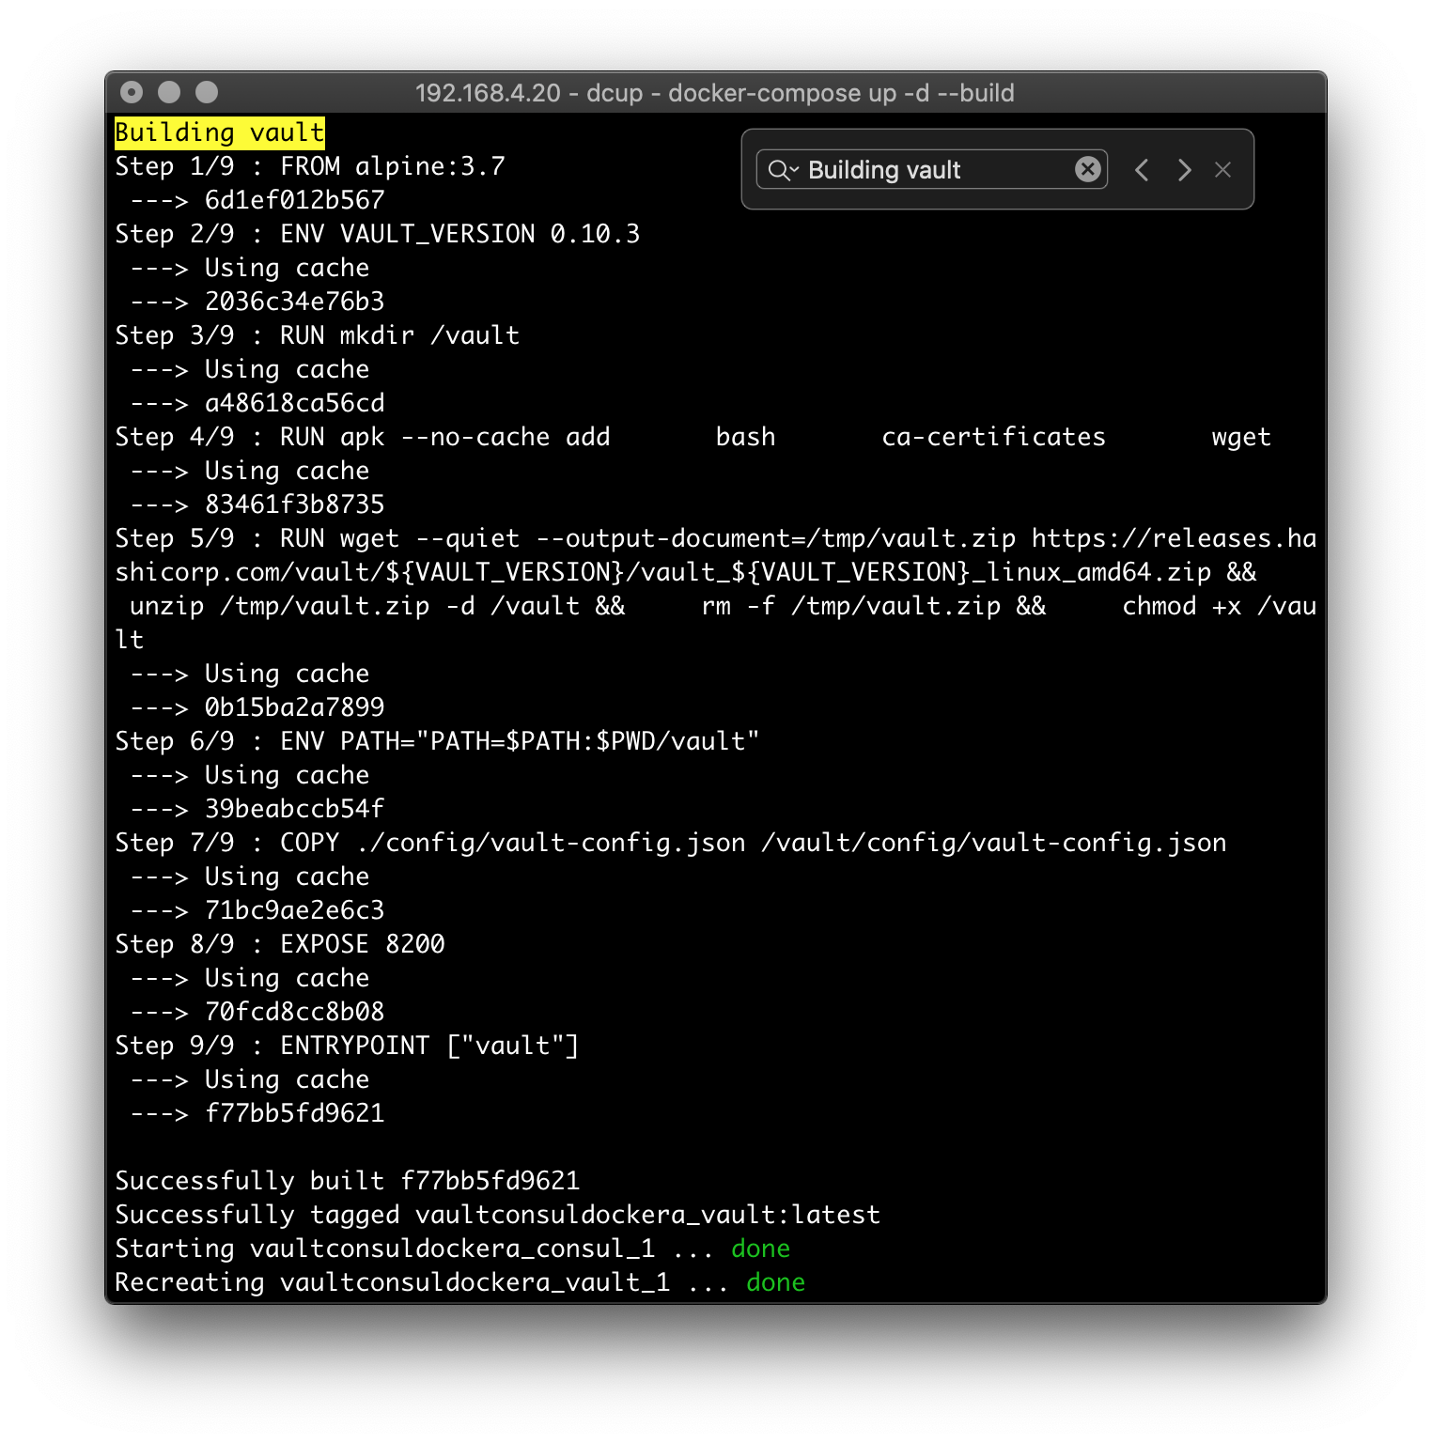



Verification (single Consul Node)

This command verifies that the scaffolding code used for the two newly-configured Docker Images (Consul, Vault) have been successfully reified:

docker ps --format "table {{.ID}}\t{{.Names}}\t{{.Status}}"

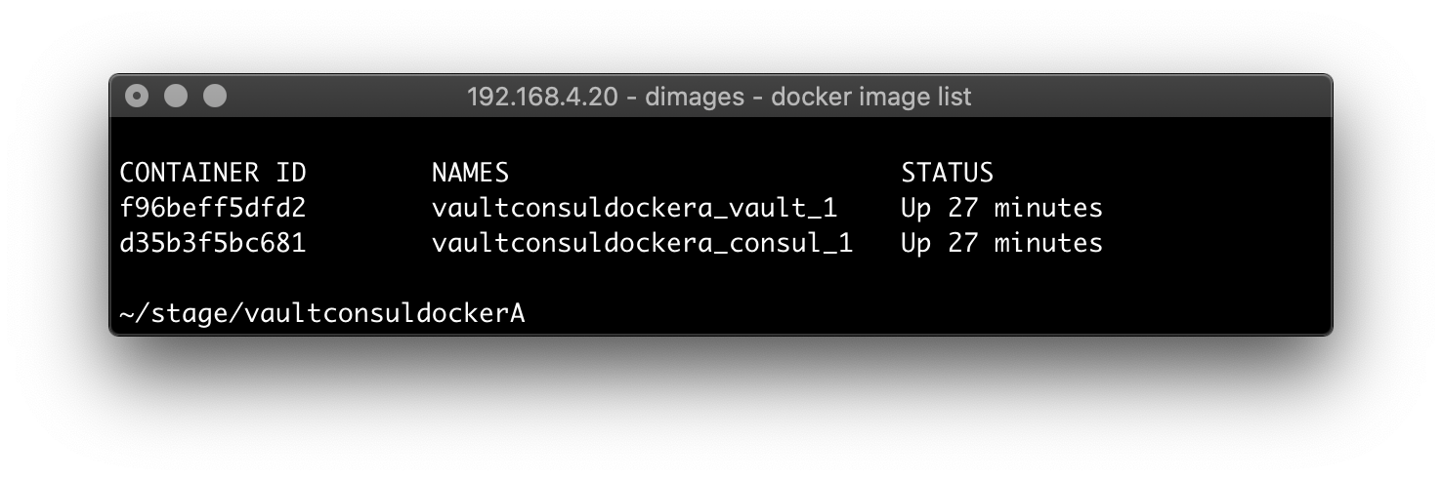



Vault and Consul (the cluster)

To add another Consul node to a Docker Container, modify the canonical file with another entry (lines 35-43), as shown below.

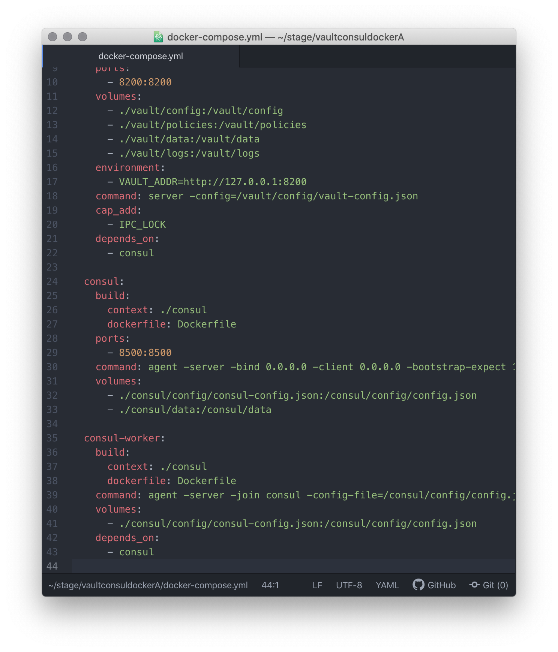

Verification (clustered Consul)

This command verifies that the configuration of new Consul node has been successfully reified:

docker ps --format "table {{.ID}}\t{{.Names}}\t{{.Status}}"

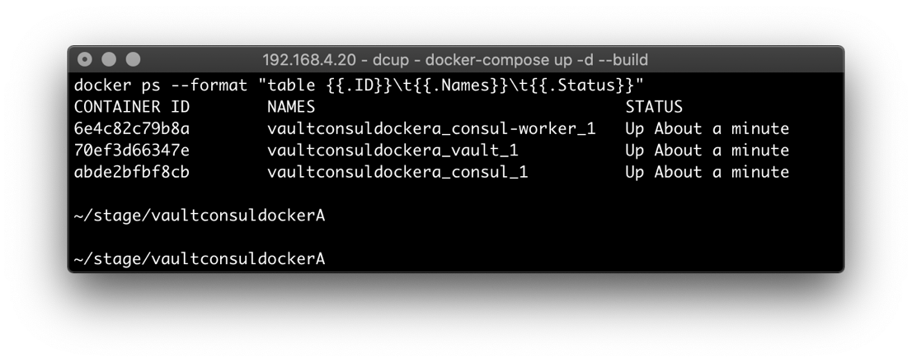



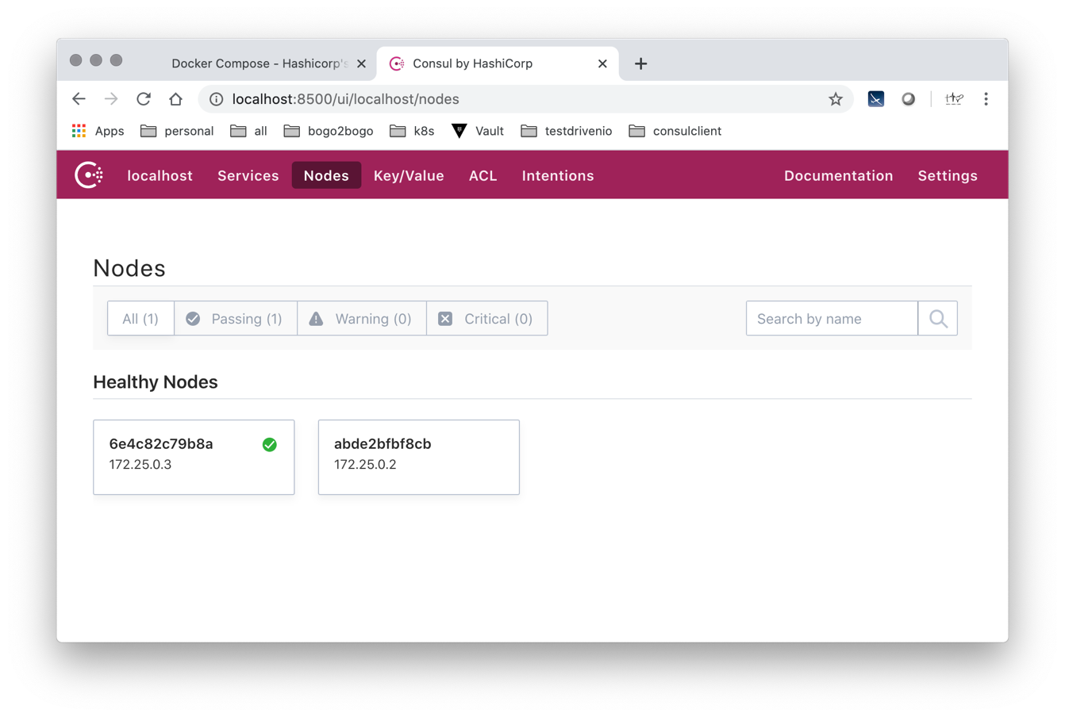

<http://localhost:8500/ui/localhost/services/consul>

nothing else